**Escape and evacuation routes**

Whenever a forest fire may occur and affect populated areas or also puts in risk a group of people, the mobile App will facilitate the evacuation of the App users, with this procedure:

1. **Escape route guidance using SoFia mobile App**

- App user conects to SoFiA App

- App user selects the function that drives away the user from forest fire.

- SoFiA App sets your position with mobile GPS, and indicates where the fire is.

- By applying the data obtained, the AI discards unsafe escape routes and shows you through SoFiA App the safe routes to escape from risky zone.

- SoFiA shows in GREEN colour the safe routes to escape from the place where the user is without without risk.  
 - SoFiA shows in RED colour the routes that are not safe from the place where the user is.

- SoFiA App would be able to connect with Google Maps to guide to a the final place you set, taking into account fire data and the routes the user should avoid.

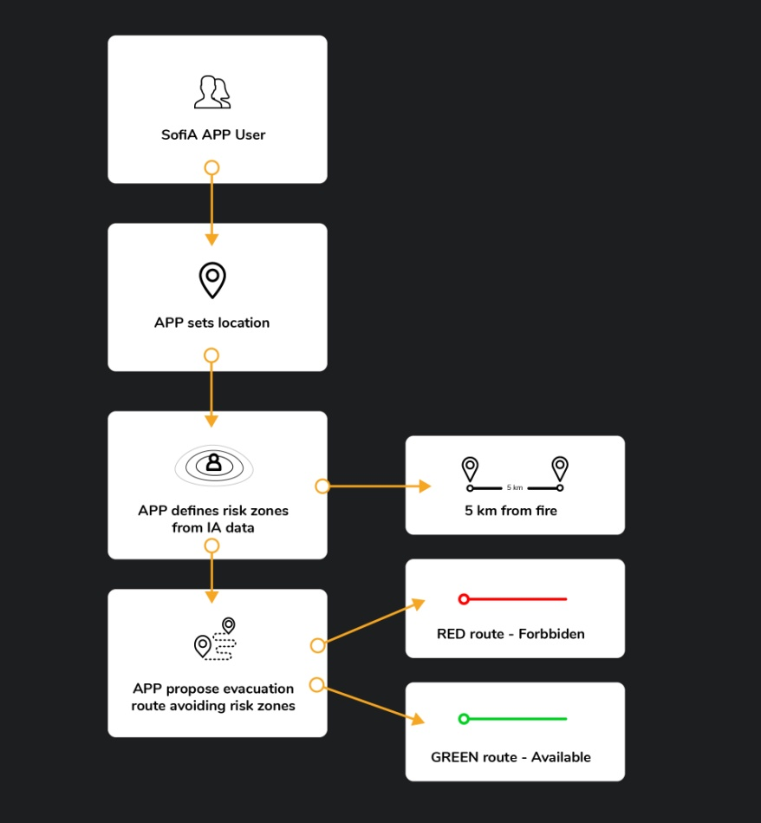

1. **Fire escape evacuation discretion for the mobile App and the App users**

Alerts to App users

**Any App user inside of a 15 km radius from a forest fire will be warned.**

Three emergency evacuation radius from forest fire are set:

- 1 km - RED ZONE - Urgent evacuation, high risk for the App user.   
 - 5 km - ORANGE ZONE - Evacuation required, moderate risk for the App user.  
 - 15 km - YELLOW ZONE - Preventive evacuation, moderate risk for the App user.

Evacuation routes criteria for the mobile App

All evacuation routes from one specific point that a user may have on normal conditions, will be evaluated by AI and the ones inside 5km radius from the forest fire, will be discarded and marked as not usable in red colour.   
On another side, the safe ones that potentially will not be affected by forest fire, will be shown in GREEN colour and eligible for the App user.

**SAFETY MEASURES IN CASE OF FIRE**

**SELF PROTECTION IN FOREST FIRE**

**If you are inevitably and unexpectedly close to a forest fire:  
  
Call urgently any local authority** and follow the instructions they will give to you.

In case of being a **small fire**, **try to extinguish it** with water or even putting sand on it, but always prioritizing your safety.

In case of being **prominent fire**, **move away opposite the smoke direction**. Cover your nose and mouth with a wet cloth for breathing.

Don't try to refuge yourself in any talweg, and in case of being on a mountain slope, **move away always on downhill direction.**Never try to escape form fire in uphill direction, couse fire moves always on uphill direction.

**Never try to cross the fire flames**, unless you have no other choice.

If your clothes are getting burned, don't run: throw yourself to the ground, and in case of having a blanket, cover yourself with it and fire will get extinguish.

Don't throw water to electric cables.

In case an helicopter is throwing water to extinguish the fire, try to avoid being under it.

In case of evacuation, **give priority to elder people, child and disable people.**

When being part of a family or group in a fire risk zone, evacuate all in a close group.

**HOUSE CONFINEMENT IN FOREST FIRE**

**If you are surprised by forest fire being close to a house or refuge and evacuation is not possible:**

**Call urgently any local authority** and follow the instructions they will give to you.

**Facilitate the entry to your property to any extinguisher authority.**

Use the hose to soak the roof and the house perimeter.

Wait inside the house till the fire gets extinguished, with all doors, windows and blinds closed.

Plug up all window and doors slits with wet cloths.

**Disconnect all flammable house supply ( gas, gasoline, petrol, etc.)**

**Disconnect power supply from the main source.**

Houses can be a safe refuge in case of forest fire. Try to stay calm in this situations and always follow emergency authority procedures for evacuation.